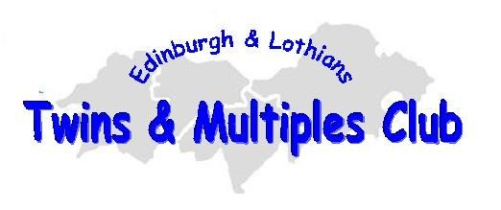
Family Membership Form

As members, your family will receive a membership card, access to all Twins Club activities, social events, toddler and babies groups, support and advice and a quarterly newsletter, plus access to TAMBA information, leaflets and publications

If you wish to join the Edinburgh & Lothian Twins & Multiples Club, please fill in the details below and return the form to the following address:

Helen Gillies
41 Haymarket Crescent
LIVINGSTON
EH54 8AP
01506 591950

Family Surname
Mother | Father
Twin/Triplet | 1. |  | 2. |  | 3.
Date of birth (or estimated date of delivery)
Name and  date of birth of siblings |  | 1. | 2. |  | 3.
Address
Postcode
Telephone No.
E-mail

I enclose a cheque to the value of £10.00 payable to “Edinburgh Twins Club”

I have no objection / object* to my family details being held on the database and being contacted by email.

I have no objection / object* to my family being put in touch with other families of twins/triplets in my area.

I have no objection / object* to my family being welcomed as a new member in our Newsletter.

In order to promote friendships and support within the club, we periodically circulate a contacts list of club members with the following details: Name of member(s), DOB of twins/triplets, abbreviated postcode (eg EH10) and telephone number. I have no objection / object* to my family being included in this list.

We would like to take photographs of our social events only for use in publicity material issued by the Edinburgh & Lothians Twins & Multiples Club, including our newsletter and website. I have no objection / object* to photographs of my children to be included.
* DELETE AS PREFERRED
How did you learn about the club?

Signed | Date

